Traction Control (TCS) OFF Telltale - Heavy Vehicles Only – CGEA1.1/1.2/1.3

Functional Description

This STSS is only used for applications which must comply to FMVSS 136 (Electronic Stability Control Systems for Heavy Vehicles) instead of FMVSS 126 (Electronic Stability Control Systems for Light Vehicles). As of initial release of this STSS H567 is the only Ford product that is classified as a heavy vehicle.

2019 H567 is intended to be fully compliant to FMVSS 136 regulation. Prior model year uses the ESC malfunction telltale to convey that the TCS has been turned off by the operator. H567 is a heavy vehicle and as per FMVSS 136 neither the ESC malfunction telltale nor the ESC Off telltale (used on all other applications) are allowed to be used to indicate that TCS has been turned off by the operator. For heavy vehicles the ESC Off telltale cannot be used to indicate TCS Off because unlike FMVSS126, as per FMVSS 136 the ECS system is never allowed to be turned off (when TCS is turned off the stability requirements are still met).

The TCS Off telltale is not regulated. The purpose of the TCS_Off_Telltale is to inform the driver that they have turned Traction Control System off.

The TCS_Off_Telltale correlates the DrvSlipCtlOffLamp_D_Rq Signal and the Operational_Mode to illuminate or extinguish the TCS Off Telltale.

Interfaces

Interface Context Diagram (I/O Block Diagram)
Figure 1 TCS_Off_Telltale Context Diagram

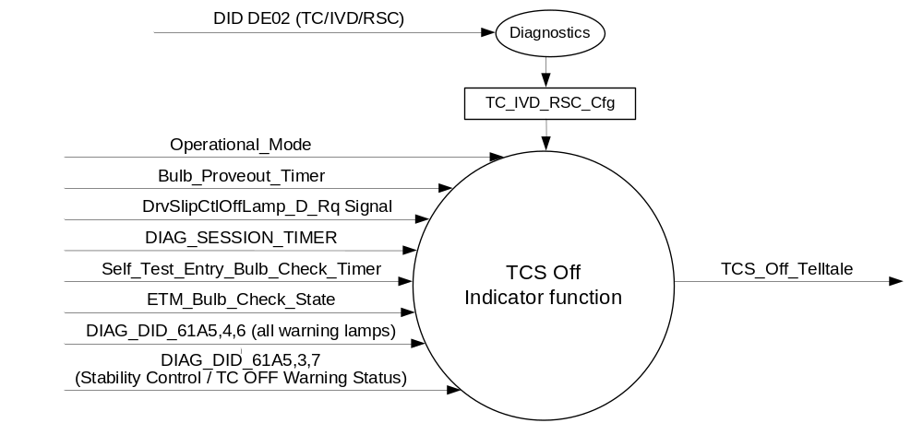

Inputs
      - INTERNAL:
            - DIAG_SESSION_TIMER
            - Operational_Mode
            - Bulb_Proveout_Timer
            - DIAG_DID_61A5,3,7 (Stability Control / TC OFF Warning Status)
            - DIAG_DID_61A5,4,6 (all warning lamps)
            - ETM_Bulb_Check_State
            - Self_Test_Entry_Bulb_Check_Timer

      - MUX message on the CAN Bus from ABS_ESC

- DrvSlipCtlMde_D_Ind Signal
Signal Name | Size  (bits) | Detail | Units | Res. | Offset | State Encoded | Min. | Max.
DrvSlipCtlOffLamp_D_Rq | 2 |  | SED | 1 | 0 |  | 0  (0x0) | 3  (0x3)
DrvSlipCtlOffLamp_D_Rq |  | Off |  |  |  | 0x0
DrvSlipCtlOffLamp_D_Rq |  | On |  |  |  | 0x1
DrvSlipCtlOffLamp_D_Rq |  | Slow_Flash |  |  |  | 0x2
DrvSlipCtlOffLamp_D_Rq |  | Fast_Flash |  |  |  | 0x3

Outputs
TCS_Off_Telltale, which is used to control the state of the LED

Function/Performance

Operational Modes

Mode | Differentiating Vehicle Conditions
Sleep Mode | TCS_Off_Telltale = OFF
Limited Mode | TCS_Off_Telltale = OFF
Normal Mode | TCS_Off_Telltale = ON/OFF
Crank Mode | TCS_Off_Telltale = ON/OFF

Voltage Levels

Refer to the Cluster Features table located in the Operational Modes and Voltage Range Strategies Section in this SPSS

Human-Machine Interface

Visual

Indicator Graphics / Display Format
TCS
OFF

For actual symbol definition refer to Approved Symbols and Abbreviations List as per ARL requirement 03-0685.

Indicator Color Coordinates

Amber – Reference SDS IL-0017/IS-0379

Indicator Characteristics

LED – TCS Off Telltale.

Audio

None

Switch Control Logic

Not applicable.

System Accuracy

The TCS_Off_Telltale shall change the state of the Telltale within 100msec of a state change as
indicated in the state matrix reference 1.3.5.1 Subsystem Algorithm Flowchart/ State Diagram

Operation: Performance and Functional

Subsystem Algorithm Flowchart / State Diagram
- State Matrix for TCS OFF Telltale
Operational_Mode | TC_IVD_  RSC_Cfg | ETM Bulb_ Check_State | DIAG_  SESSION_  TIMER | Self_Test_ Entry_Bulb_ Check_Timer | DIAG_DID_  61A5,3,7  (Stability Control / TC OFF Warning Status) | DIAG_DID_  61A5,4,6  (all warning lamps) | Bulb_  Proveout_Timer | DrvSlipCtlOffLamp_D_Rq Signal | ESC_Off  _Telltale
Normal or Crank | 1, 2 or 3 | X | Inactive | X | X | X | Active | X | ON
Normal or Crank | 1, 2 or 3 | X | Inactive | X | X | X | X | On (0x1) | ON
Normal or Crank | 1, 2 or 3 | ON (0x1) | Inactive | X | X | X | X | X | ON
Normal or Crank | 1, 2 or 3 | OFF (0x0) | X | Inactive | Not Received | Not Received | Not Active | Missing as per 1.4.1 | OFF
Normal | 1, 2 or3 | X | Active | Inactive | Not Received | Not Received | Active | X | ON
Normal | 1, 2 or3 | X | Active | Inactive | Not Received | Not Received | X | On (0x1) | ON
Normal | 1, 2 or3 | ON (0x1) | Active | Inactive | Not received | Not Received | X | X | ON
Normal | 1, 2 or3 | X | Active | X | ON (0x1) | X | X | X | ON
Normal | 1, 2 or3 | X | Active | X | X | ON (0x1) | X | X | ON
Normal | 1, 2 or3 | X | Active | Active | X | X | X | X | ON
All Other Cases |  |  |  |  |  |  |  |  | OFF
X= Don’t Care
Never Received = The state of no message received and missing message timer not yet expired
Not Received = The state when a DIAG_SESSION_TIMER is active and the DID has not been received

Operation Description (supports algorithm flowchart /state diagram)

- TCS_Off_Telltale shall reflect signal state within 100 mS of receipt of DrvSlipCtlOffLamp_D_Rq Signal.

Function Safety Classification (EMC)

Class B

Memory Storage

Parameter Name | Description | Value at  Battery Connect | Value at  Module Wake-up
TCS_Off_Telltale | Used to control the state of the LED | OFF (0x0) | OFF (0x0)
DrvSlipCtlOffLamp_D_Rq | CAN signal sent from the ABS_ESC | Off (0x0) | Off (0x0)
TC_IVD_RSC_Cfg | State Indicator for feature presence controlled via CAN at EOL at VO plant. Set to Disabled (0x0) at cluster supplier manufacturing plant. | Use Stored Value | Use Stored Value
DIAG_DID_61A5,3,7 (Stability Control / TC OFF Warning Status) | Warning Lamp Status 2, byte 3, bit 7 (Stability Control / TC OFF Warning Status) | 0 (0x0) | 0 (0x0)
DIAG_DID_61A5,4,6 (all warning lamps) | Warning Lamp Status 2, byte 4, bit 6 (all warning lamps) | 0 (0x0) | 0 (0x0)
ETM_Bulb_Check_State | State indicator for warning bulb in ETM | OFF (0x0) | OFF (0x0)
Operational_Mode | 4 state indicator for cluster operational mode | Limited | Limited or Normal or Crank

Parameter Name | Description | Value at Battery Connect | Value at Module Wake-up
DIAG_SESSION_TIMER | Timer used to time-out a diagnostic session | Not Active | Not Active
Bulb_Proveout_Timer | Internal command directing proveout | Not Active | Not Active
Self_Test_Entry_Bulb_Check_Timer | Timer used in diagnostic session to do a self check of telltales | Not Active | Not Active

Prove Out

3.0 +/- 0.1 seconds as per bulb prove out section. Prove out (bulb check required per regulation).
Cluster controls prove out.

Reconfigurable Telltale

No

Message Center Msg

None

Error Handling

Missing Message Strategy
The signals will be declared missing as per the Diagnostics section of this SPSS.

DTCs states and history will be determined as per the Diagnostics section of this SPSS.

If TC_IVD_RSC_Cfg = Disabled, the cluster shall never log a missing message DTC for this feature.

Diagnostics

Self Test

Bulb illuminated during self test as per Self_Test_Bulb_Check_Timer

Engineering Test Mode

Reference section “Dealer / Engineering Test Mode (ETM)”

Part II Performance

Supported Diagnostic DIDs (Service $22 and $2F)
Number | DID / CommonID Name | DID Type
61A5 | Warning Lamp Status 2, byte 3, bit 7 (Stability Control / TC OFF Warning Status) | Bit Mapped
61A5 | Warning Lamp Status 2, byte 4, bit 6 (all warning lamps) | Bit Mapped

Supported Diagnostic Trouble Codes (DTCs)

DTCs shall be logged as per the diagnostic section of this SPSS.

DTC | Description
C12100 | Lost communication with anti-lock brake system (ABS) control module

DID DExx
Block  Num | Block Description | Size (bits) | Type | Byte(s) | Bits | State: Description | "0" | "1" | Default | Comments/  Information
PACKETED BLOCKS
$02 | Option Content (B&A) | 32 | 1 | * | * | TC/IVD/RSC | Encoded | Encoded | 0
 |  |  |  |  |  | 0 | Encoded | Encoded |  | 0 - Disabled
 |  |  |  |  |  | 1 | Encoded | Encoded |  | 1 – TC
 |  |  |  |  |  | 2 | Encoded | Encoded |  | 2 – IVD
 |  |  |  |  |  | 3 | Encoded | Encoded |  | 3 - RSC
*Byte and bit location to be identified in Part II Specification for this cluster

Reference Specification

AN-0008 BRAKE CONTROL ON/OFF SWITCH AND LIGHTS DEFINITION
AN-0263 BRAKE CONTROL MODES OF OPERATION

IS-0001 WARNINGS/INDICATORS/DISPLAYS PROVEOUT
IS-0046 INSTRUMENTATION MATERIAL RESISTANCE TO CLEANING
IS-0052 OPERATING VOLTAGES - FUNCTIONAL/PERFORMANCE
IS-0069 FUNCTIONAL IMPORTANCE CLASS
IS-0324 WINDSHIELD & OTHER REFLECTIONS
IS-0327 WARNING INDICATOR EVALUATION
IS-0329 FLICKERING OF LAMPS
IS-0379 NORTH AMERICAN WARNINGS AND INDICATORS STRATEGY

IL-0017 TELLTALE AND INTERIOR ILLUMINATION COLOR
IL-0021 CRAFTSMANSHIP - DISPLAYS
IL-0023 CLARITY/LEGIBILITY/READABILITY
IL-0025 INTERIOR ILLUMINATION INTENSITY
IL -0027 VISUAL CONTRAST
IL -0043 OPERATIONAL ENVIRONMENT FUNCTIONALITY
IL -0045 COLOR
IL -0047 TELLTALE; INDICATOR AND DISPLAY LIGHT INTENSITY
IL -0048 ILLUMINATION ACCEPTABILITY

03-0661 PLACEMENT: CONTROL AND DISPLAY LOCATIONS
03-0662 PLACEMENT: LOGICAL GROUPING FUNCTION AND USAGE
03-0664 PLACEMENT: DOWN VISION TO COMPONENTS WITH HIGH VISUAL DEMAND
03-0665 PLACEMENT: EXPECTED LOCATIONS OF CONTROLS AND DISPLAYS VDS
03-0670 INTERIOR VISIBILITY
03-0671 INTERIOR VISIBILITY: REFLECTIONS FROM COMPONENTS & SURFACES
03-0672 INTERIOR VISIBILITY: REFLECTIONS IN DISPLAYS
03-0673 INTERIOR VISIBILITY: VISUAL OBSCURATIONS
03-0674 INTERIOR VISIBILITY: ILLUMINATION CONTROLS / DISPLAYS
03-0675 INTERIOR VISIBILITY: VEILING GLARE
03-0677 INTERIOR VISIBILITY: SUNLIGHT WASHOUT
03-0681 IDENTIFICATION: CHARACTER AND SYMBOL SIZE
03-0682 IDENTIFICATION: LEGIBILITY
03-0685 IDENTIFICATION: SYMBOLS, ABBREV FOR CONTROL
03-0721 LOGIC OF OPERATION: OPERATIONAL STEREOTYPES
03-0722 LOGIC OF OPERATION: INTERPRETATION
03-0723 LOGIC OF OPERATION: USE OF SYSTEMS WITH VISUAL DISPLAYS

Revision History

SPSS Module Revision History

Revision Level | Name | Change Description | Date
1.0 | J. Blatchford | Initial Release to support 2019 H567 program. | 2/19/2017

